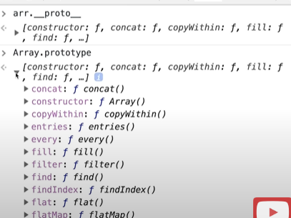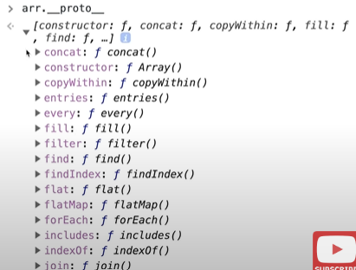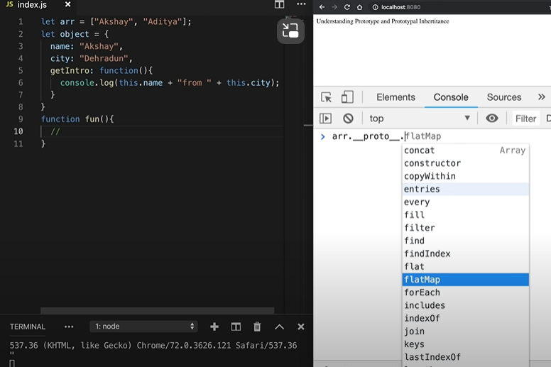

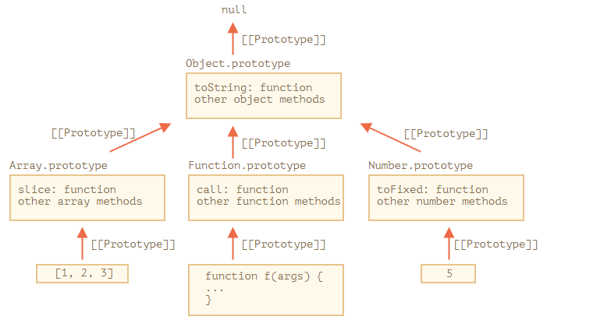Each & Every Object is have an protype.

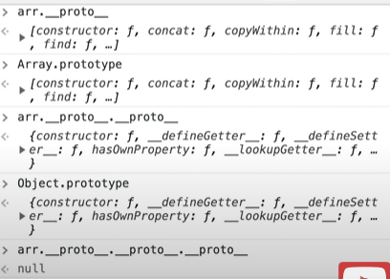Prototype Chain:-



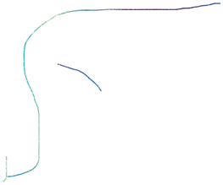





Array.prototype.__proto__==arr.__proto__.__proto__==Object.prototype

Array.prototype.__proto__.__proto__==arr.__proto__.__proto__.__proto__==Object.prototype.__proto__==null

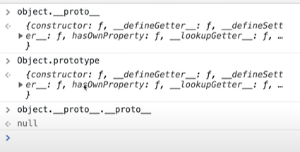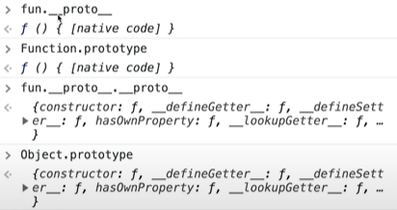

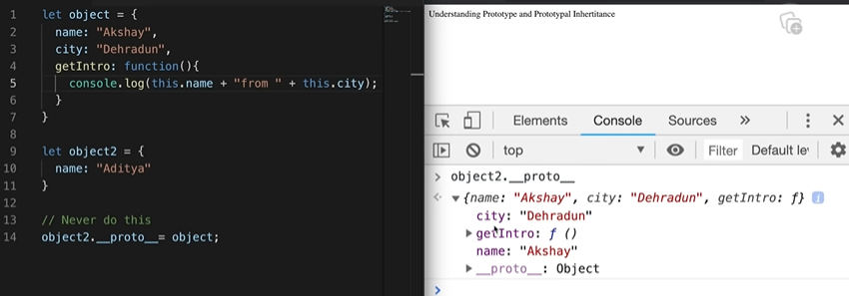Prototypal Inheritance



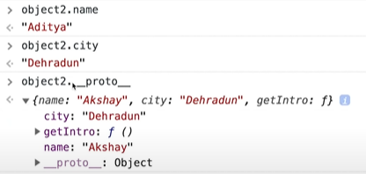

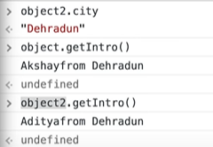

 First find inside nearest prototype then go up.

But object2=object//full transfer

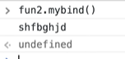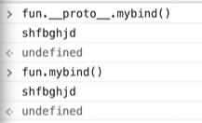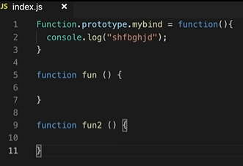



Function.prototype.mayank = function() { console.log("shfbghjd");}

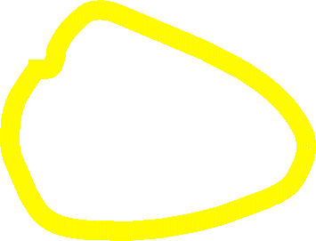

function fun() { // some code}

function fun2() { // some code}

fun.mayank(); // This will log "shfbghjd"

All JavaScript objects inherit properties and methods from a prototype.